**计算器实验报告**

一．计算器界面及操作

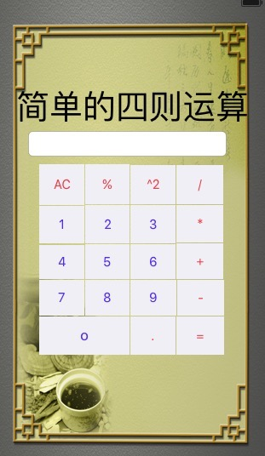

实现计算器加减乘除的基本功能，并处理了简单的bug，小数点问题等问题。

二·代码及功能

import UIKit

class ViewController: UIViewController {

@IBOutlet weak var show: UITextField!;

var opeRand1: String = ""

var opeRand2: String = ""

var opeRator: String = ""

var dianLopp=false;

var result = 0.0;

override func viewDidLoad() {

super.viewDidLoad()

// Do any additional setup after loading the view, typically from a nib.

}

override func didReceiveMemoryWarning() {

super.didReceiveMemoryWarning()

// Dispose of any resources that can be recreated.

}

@IBAction func add1(sender: UIButton) {

show.text!+="1";

}

@IBAction func add2(sender: UIButton) {

show.text!+="2";

}

@IBAction func add3(sender: UIButton) {

show.text!+="3";

}

@IBAction func add4(sender: UIButton) {

show.text!+="4";

}

@IBAction func add5(sender: UIButton) {

show.text!+="5";

}

@IBAction func add6(sender: UIButton) {

show.text!+="6";

}

@IBAction func add7(sender: UIButton) {

show.text!+="7";

}

@IBAction func add8(sender: UIButton) {

show.text!+="8";

}

@IBAction func add9(sender: UIButton) {

show.text!+="9";

}

@IBAction func add0(sender: UIButton) {

show.text!+="0";

}

@IBAction func addDain(sender: UIButton) {

if(!dianLopp)

{

show.text!+=".";

dianLopp=true;

}

}

@IBAction func delt(sender: UIButton) {

show.text!="";

opeRand1="";

opeRand2="";

dianLopp=false;

}

@IBAction func add(sender: UIButton) {

setx();

opeRator="+";

}

@IBAction func jian(sender: UIButton) {

setx();

opeRator="-";

}

@IBAction func cheng(sender: UIButton) {

setx();

opeRator="*";

}

@IBAction func chu(sender: UIButton) {

setx();

opeRator="/";

}

@IBAction func chu100(sender: UIButton) {

result = Double(show.text!)!/100;

}

@IBAction func pwd(sender: UIButton) {

let tmp=Double(show.text!)!*Double(show.text!)!//静态 只能赋一次值

show.text!="\(tmp)";

}

@IBAction func count(sender: UIButton) {

opeRand2=(show.text!);

switch opeRator {

case "+":

result = Double(opeRand1)! + Double(opeRand2)!

case "-":

result = Double(opeRand1)! - Double(opeRand2)!

case "*":

result = Double(opeRand1)! * Double(opeRand2)!

case "/":

result = Double(opeRand1)! / Double(opeRand2)!

default :

result=0

}

show.text! = "\(result)"

opeRand1 = ""

opeRand2 = ""

opeRator = ""

}

func setx(){

opeRand1=(show.text!);

show.text!="";

dianLopp=false;

}

}